Forum: General Assembly
Issue: Reducing the Rapid Spread of Digital Misinformation
Student Officer: Bennett Tung
Position: President of the General Assembly
Introduction
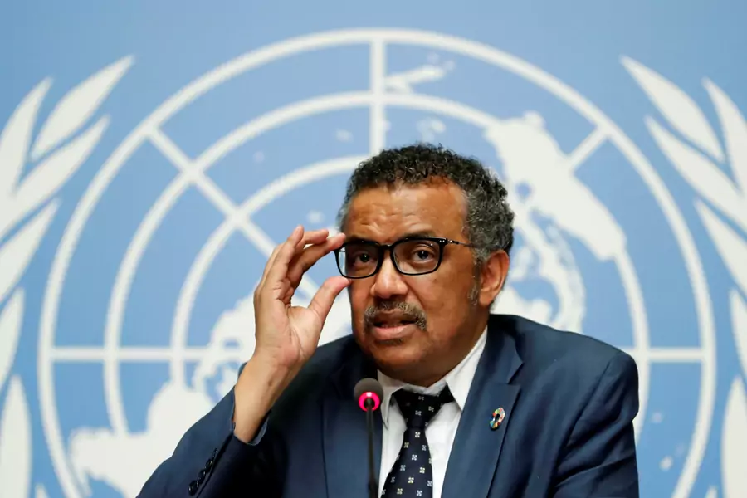
Figure #1: Director General of WHO discusses misinformation during the COVID-19 pandemic
“We’re not just fighting an epidemic; we’re fighting an infodemic,” proclaimed the World Health Organization’s Director General, Dr. Tedros Adhanom Ghebreyesus, at a Munich security conference in 2020. Amidst the COVID-19 pandemic that ravaged the world, Dr. Tedros was highlighting a different issue that had been developing for decades: the rise of digital misinformation.
The term “misinformation” refers to any misleading information that is spread. Thus, misinformation encompasses disinformation, which refers to instances where false information is deliberately shared with the intent of deceiving people. As a result, misinformation can be exploited for an underlying agenda. Regardless of whether a post is shared out of ignorance or malice, users of online platforms like Instagram, YouTube, TikTok, Facebook, etc. are vulnerable to these falsehoods, and in a society where information is the lens through which humans perceive the world, the repercussions are vast and severe.
A recent Pew Research study found that 86% of adults get their news from a smartphone, demonstrating the dependence the global community has on online platforms for accessing information. While the emergence of such platforms has produced progressive movements like the Arab Spring in 2011 and the #MeToo movement in 2017, it has also produced dangerous and regressive movements like the anti-vaccine movement and the January 6th United States Capitol attack largely due to the circulation of misinformation.
Misinformation has infiltrated how society views almost all aspects of life, such as disaster response, health, environmental conservation, and politics. In times of disaster, misinformation generates unnecessary panic that impedes the ability of authorities to fulfill their duties and supports hidden underlying political agendas. In tackling public health crises, misinformation has scared people away from seeking prevention procedures like vaccines by crafting false narratives about their risk. Ironically, misinformation has simultaneously encouraged people to take on dangerous treatments like ingesting alcohol-based cleaning products which are devoid of scientific support. Moreover, despite the Earth’s increase in irregular flooding, heatwaves, and storms in recent years, climate change deniers and skeptics cling onto misinformation as a basis for their beliefs, emboldened by advertisements and rhetoric produced by powerful oil and gas companies. In addition, the 2019 EU elections, 2019 Indian elections, and 2016 American elections were all influenced by falsehoods spread across the internet. Scandals such as Cambridge-Analytica and India’s disinformation campaign against Pakistan all serve to prove that misinformation undermines the ability of a country to carry out a democracy.
Past solutions have mainly been resting on the shoulders of governmental regulation and the online platforms themselves. For example, the EU blocked Russia’s top channels of news such as RT and Sputnik upon determining that those channels were spreading false, pro-Russia propaganda about Russia’s invasion of Ukraine in February 2022. Platforms like Facebook, Instagram and Twitter began flagging untrustworthy posts on their platforms to warn users about potential misinformation. But these solutions are not able to cover all information spread on the internet. Future solutions may include a more preventative approach, calling on journalists and authorities to educate the public before discourse can escalate online. Curriculums within schools and education programs centered on evaluating the credibility of online sources can also produce a better-informed generation of netizens.
Definition of Key Terms
Misinformation
Misinformation is any incorrect or misleading information that is spread, including that which is intended to mislead or deceive people.
Disinformation
Disinformation is false or misleading information that is spread with the intent to mislead or deceive people.
Mal-information
Mal-information is true information that is used in certain contexts o
Rumor
A rumor is unverified information or statements that circulate with uncertainty.
Confirmation Bias
Confirmation bias is the tendency of a person to support information that reinforces pre-existing beliefs and neglects opposing perspectives.
Social Bias
Social bias is the tendency of a person to trust information received from a person they know or identify with over information from other sources.
Echo Chamber
Within the context of social media, an echo chamber is used to refer to the tendency of an online platform to suggest content aligning with the user’s established beliefs. Thus, it is as if their views are “echoing” back at them, rather than exposing them to opposing perspectives.

History & Developments
Causes of misinformation’s rapid spread
Researchers have spent years studying the cause of misinformation’s prevalence. The main causes are convenience of transmission, social bias, confirmation bias, algorithm design, and emotional responses. Given how easy it is to reshare or forward posts to other users online, it takes minimal thought and certainly minimal fact-checking to spread misinformation. This ease is the reason that misinformation can spread with such efficiency.
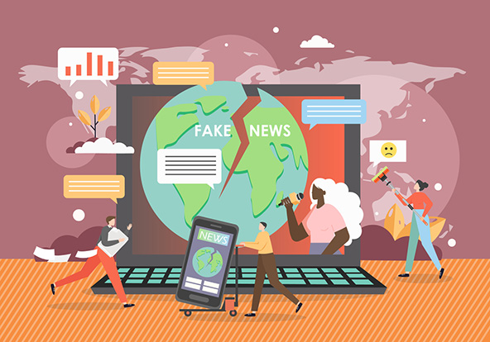
Figure #2: Artwork depicting misinformation’
Human and algorithmic biases
Social bias is encoded in the human psyche; it means that humans are conditioned to trust information shared by people they know or trust. This bias encourages people to trust information despite the ambiguity of where the information is coming from as long as someone they are familiar with has chimed in. Adding to that social bias is confirmation bias. People tend to search for information that confirms their established beliefs and neglect information that produces cognitive dissonance. For example, someone who is opposed to vaccination may search for information about the risks of vaccines and turn a blind eye to data about its benefits. Because of these human biases, algorithms themselves adopt biases as well. The point of a social media algorithm is to show users content that they will likely enjoy, so these algorithms are more inclined to show content that already aligns with the user’s beliefs and preferences, avoiding any opinions that might challenge their own. That is why social media is often referred to as an echo chamber. Misinformation spreads rapidly within these echo chambers as not only do similar posts with inaccuracies seem to concur with one another, but there are no opposing viewpoints challenging these falsehoods.
Emotional response
To make matters worse, anxiety and stress amidst times of uncertainty lead people to search and share information that fill gaps in their knowledge as a coping mechanism. In the process, they are usually blinded to the lack of credibility in certain online sources, especially when there is a dearth of sources speaking on the topic to begin with. For example, in the early stages of the COVID-19 pandemic, there was not as much reliable information on the internet, leading people to seek out unreliable sources of information that encouraged them to ingest cleaning products. In fact, people are more likely to share information that they find alarming or threatening, partially out of altruistic behavior to warn their peers. Because alarming content tends to have more dramatic user interactions, the algorithm of the platform then perceives it as quality information and spreads it further despite never validating the truth of the content.
Disinformation campaigns
Disinformation campaigns often focus on targeting certain demographics and appealing to emotion, which can mislead people into spreading their claims. Amidst Russia’s invasion of Ukraine, the Russian government was using misinformation against citizens across the world to lessen the outrage of the international community. Similarly, oil and gas companies have long been funneling cash into Facebook and YouTube ads that sway people against climate action for their own financial gain. Ergo, underlying intent by an organization can also be a driving force in spreading misinformation.
Disaster response
As previously mentioned, times of crisis often jumpstart the spreading of misinformation online because of the anxiety it induces and the gaps in knowledge that typically exist. Consequently, a common problem resulting from misinformation is the mass panic that it causes in times of crisis.
In 2018, the southern state of India known as Kerala experienced massive flooding. During this, a video of a man dressed as an army officer claimed that the Kerala Chief Minister Pinarayi Vijayan was stopping the army from conducting rescue operations. This video subsequently went viral, but these claims were not true, merely invented by someone trying to undermine the government’s authority. Furthermore, an audio clip warned the Muliaperyiar Dam nearby was about to collapse from the flooding and circulated amongst the community, but this was untrue as well. In both instances, a false rumor incited panic amongst the citizens of Kerala, giving the authorities yet another issue to worry about amidst a flooding catastrophe.
Figure #3: A misleading post circulated online during the Kerala floods in 2018
Studies have shown that authorities must address sources of confusion immediately after a crisis occurs to prevent the circulation of falsehoods online. During the Boston Marathon bombing in 2013, tweets that were made right after the disaster occurred tended to have more influence on Twitter discussions than tweets made slightly later, proving that early responses are critical for setting the record straight.
COVID-19 and other health misinformation
As of the writing of this report, estimates show that the COVID-19 pandemic has amassed roughly 6.5 million deaths globally. During public health emergencies, effective communication is critical for containing and treating the virus, which is where misinformation is a major obstacle. Conspiracies surrounding vaccines like the COVID-19 vaccine spurred the anti-vaxx movement, and baseless claims about odd miracle treatments led to the reckless consumption of dangerous chemicals.
Anti-vaccine movement
The anti-vaccine movement is as old as the conception of vaccines itself. In fact, the rationale behind rejecting vaccination has remained largely unchanged: fears of side effects, questions of efficacy, and rejection of government control. In fact, the mass protest against vaccine mandates introduced to defeat smallpox in the 19th century parallels the reaction to the potential enactment of COVID-19 vaccine mandates in the 21st century.
But misinformation can replace understandable wariness with a solidified belief in strange conspiracy theories. A measles outbreak at Disneyland in California propelled harmful anti-vaccine rhetoric forward on Twitter. At the early stages of COVID-19 vaccine introduction, a YouGov poll suggested that 28% of Americans believed Bill Gates was using vaccines as a coverup for a scheme to implant microchips in people. Furthermore, posts where children “died on the spot” after getting vaccinated against COVID-19 in Senegal were shared more than 7000 times on Facebook amid a vaccination campaign. As a result, more people were driven away from vaccination booths and were more vulnerable to contracting and spreading the virus forward.
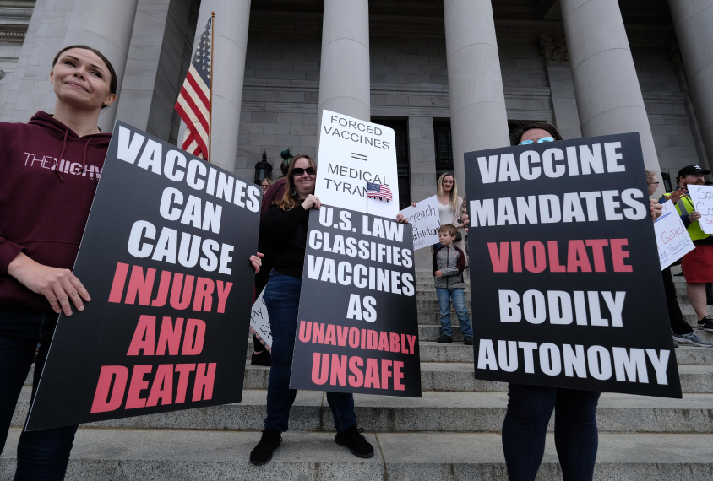
Figure #4: Anti-vaxxers protest a potential COVID-19 vaccine mandate
Popularization of dangerous treatments
A study from the American Journal of Tropical Medicine and Hygiene previously estimated that around 5800 people have been admitted to the hospital because of misinformation regarding COVID-19 treatments. Rumors circulating on social media encouraged users to consume methanol or alcohol-based cleaning products, eat large amounts of garlic, ingest a plethora of vitamins, and even drink substances like cow urine. Former President Donald Trump emboldened these claims by discussing the potential efficacy of these treatments.
Misinformation in politics
In democratic nations, misinformation can become the basis from which citizens decide to vote and thus determine the outcome of the election. Recent elections, such as the 2016 and 2020 American presidential elections, 2019 EU elections, and 2019 Indian election were all influenced by misinformation to a notable degree. The Cambridge-Analytica scandal in particular awoke the world to the vulnerabilities of democratic processes. Moreover, disinformation can be used to cause domestic conflict, as with the Capitol riots in the United States, and heighten international tensions, as with India’s disinformation campaign against Pakistan in 2021.
Cambridge-Analytica
Cambridge-Analytica, a London-based political consultant agency, rose to the international spotlight when they allegedly harvested the data of roughly 87 million Facebook users to influence the 2016 Presidential election in Donald Trump’s favor. Inspired by a paper published by two University of Cambridge students in 2013 which linked Facebook activity to information about the user’s personality, Cambridge Analytica built personality archetypes that allowed them to target certain demographics with political ads. The tailored ads were compelling enough to sway certain voter’s opinions, and thus this mass disinformation campaign directly influenced the outcome of the 2016 election.
European Union elections
European Union leaders filed an official report in 2019 claiming that Russian groups were carrying out disinformation campaigns to influence the outcome of the EU election. Posts circulating on social media spread misinformation linking the collapse of Austria’s government with a “European deep state” conspiracy. Other posts pushed a narrative that the Notre-Dame cathedral in Paris burned down because of a decline in Christian values in the area.
Capitol riots in the United States
With former President Donald Trump promoting these false claims, the 2020 Presidential election was largely framed as inaccurate and a fraud by supporters of the former president. Election officials from Trump’s own party confirmed that the election was the “most secure in American history” as a result of extra precaution during the pandemic. Regardless, claims centered on the fact that mail-in ballots were manipulated to benefit now President Joe Biden eventually led to the start of a movement to storm the Capitol building in Washington D.C. On January 6, 2021, protestors forcefully entered the government building to protest the allegedly “stolen” election, emboldened by misinformation.
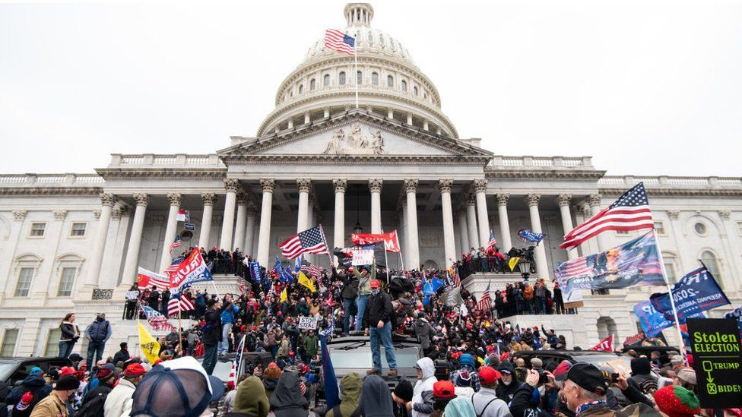
Figure #5: Protestors storm the Capitol building in the United States over claims of a stolen election
India’s disinformation campaigns
Mainstream media outlets in India participated in a disinformation campaign that blamed Pakistan for the Taliban’s takeover of Afghanistan in 2021. The claims insinuated that Pakistan bore responsibility as the Taliban’s operations were linked to the city of Rawalpindi in Pakistan. Furthermore, one channel falsely accused the Pakistani air force of aiding the Taliban in an attack despite the Pakistani government’s condemnation of the Taliban as a terrorist group.
The explosion of COVID-19 cases in India was also a catalyst for harmful rhetoric against the Muslim community. The Tablighi Jamaat congregation in Delhi, which was a Muslim congregation, was framed as the origin of a surge in cases in the country, leading to discrimination and even violent attacks against the Muslim minority in the country.
Climate misinformation
The rise of unpredictable and unprecedented weather events such as drought, floods, and storms in recent years has awoken the global community to an ongoing climate crisis. In fact, a study of academia on the topic found that 99% of scientists agree that humans are the root cause of climate change. Nonetheless, denial and skepticism, rooted in misinformation, remains. A survey of 1700 UK adults found that almost half could not distinguish fake climate change news headlines correctly more than 50% of the time, demonstrating the lack of knowledge the general public has to protect them from climate misinformation.
In many cases, companies have financial motivation to mislead people into denying the existence of climate change. 15 companies that are known to be major polluters created Facebook ads that garnered a total of 150 million impressions, all of which served to downplay the consequences of their operations. Additionally, the Texas Public Policy Foundation, which possesses strong ties with the oil and gas industry, was responsible for a YouTube ad campaign that insinuated clean energy was a direct attack on the survivability of small local businesses. On a smaller scale, greenwashing, which is when companies or organizations brand themselves as being environmentally friendly and committed to climate action, is often a deception to bring in greater profits, and it is unfortunately effective.

Geopolitics
The United States
Home to the headquarters of social media giants like Meta, Google, Twitter, and Snapchat, the United States government has immediate access to legislating and enacting restrictions against the spread of misinformation. Having experienced disinformation campaigns, such as the Cambridge Analytica scandal and the allegedly “stolen” election, throughout both the 2016 and 2020 Presidential elections, the United States has had its fair share of political trouble surrounding misinformation. An NPR poll found that 64% of Americans believe that their democracy is in crisis, much attributed to the political polarization sewn by the echo chambers of social media. Former President Donald Trump himself was infamously opposed to the media for alleged “fake news,” which brought misinformation to the forefront of political discourse. During the COVID-19 pandemic, the United States became plagued with anti-mask and anti-vaccine movements, both bolstered on digital platforms, which ultimately obstructed preventions of the virus’ spread. In recent years, Congress has proposed bills that require online platforms to make ads public and track who is buying them. States like California and Massachusetts have implemented media literacy into the curriculum of public schools. From an international perspective, the United States has repeatedly condemned the Russian government for its meddling in the 2016 Presidential elections.
The Russian Federation
The Russian government has repeatedly been accused of employing disinformation campaigns to influence elections in countries such as the United States and members of the European Union. American intelligence officials claimed that social media accounts associated with the Russian government were spreading posts aimed to support Donald Trump’s re-election in 2020. With the outbreak of the recent Russian-Ukrainian conflict, NewsGuard, an organization specialized in tracking misinformation, discovered 250 websites spreading Russian disinformation about the war. These claims accused the Ukrainian government of staging Russian attacks to garner sympathy from the international community and painted Ukrainian refugees in Germany and Poland as criminals. Since Ukraine was a major grain supplier to countries in Africa and the Middle East before the conflict, other reports claimed that Russia was framing global food shortages on sanctions made by the West rather than on the military hostilities. These Russian disinformation campaigns are allegedly facilitated through websites posing as independent news sources, which offer news in English, French, German, and Italian. Nonetheless, the Russian government has instigated a crackdown on misinformation within their own country, passing laws which enforce hefty fines on online news outlets that circulate false rumors.
The European Union
Composed largely of democratic nations vulnerable to disinformation attacks, the European Union has been particularly vigilant with their crackdowns on misinformation. In 2019, EU leaders filed a report that claimed Russian groups were carrying out disinformation campaigns amidst EU elections. In 2022, the EU began pushing a revised code of practice aimed to target deep fakes and political advertising. With 30 signatories, including Google, Meta, Twitter, and Microsoft, violators could be charged as much as 6% of the global
Social Media Companies
Social media companies have direct access to the algorithms that facilitate the spread of misinformation within their echo chambers. With pressure from governments around the world, the majority of social media giants have vowed to tackle the misinformation issue, including signing agreements with governmental organizations like the European Union. Many apps have begun flagging posts for potential misinformation and demonetizing content that goes against generally accepted science. Other reforms pushed posts made by reliable sources to users more often than less reliable ones.

Previous Attempts to Solve the Issue
Social Media Companies
Social media companies have gradually implemented algorithmic changes to prevent the spread of misinformation. In October 2021, Google announced YouTube would no longer monetize videos that denied the existence and causes of climate change. In a similar effort, Twitter, which permitted nearly half a million climate denying posts on their platform in 2020, created a specialized Climate Change Topic on their main page to promote reliable sources on the subject. They also started integrating “pre-bunking,” a technique that steers usings towards credible sources before they encounter misinformation. Many social media platforms also began flagging posts as misinformation and preventing them from being shared. Furthermore, WhatsApp, which previously allowed users to forward posts to 250 groups at a time, lowered it to just 5, and message forwarding occurred 25% less frequently overall.
Government Regulations
Governments have begun blocking known sources of misinformation online, as the EU did with Russian channels RT and Sputnik after Russia’s invasion of Ukraine. Many countries have decided to prosecute disseminators of misinformation. In countries like Russia, Brazil, Belarus, and Bangladesh, violators can face hefty fines and even jail time for spreading misinformation. Some countries like the United States and Canada, have made media literacy a more integral part of the public-school curriculum. Other regulations enforced at an international level require social media companies to be transparent about the ads that they run.
Relevant UN Treaties and Events
Established in 1978 as a subsidiary of the General Assembly, the UN’s Committee on Information is focused on ensuring effective and fair communication throughout the world. At the 44th session in 2022, member states highlighted fighting misinformation as a priority for the UN’s Department of Global Communications.
In April of 2022 at the 49th regular session of the UN’s Human Rights Council, a resolution titled, “Role of States in countering the negative impact of disinformation on the enjoyment and realization of human rights” was sponsored by Ukraine, Japan, Latvia, Lithuania, Poland, the United Kingdom, and the United States. The resolution emphasized that governments must play a primary role in countering false narratives spread online. Although it received widespread support, some countries refused to adopt the resolution. China believed the resolution focused too little on the root cause of the issue, while Vietnam claimed the resolution was biased and the sponsors themselves were guilty of starting disinformation campaigns. It was adopted without a vote.
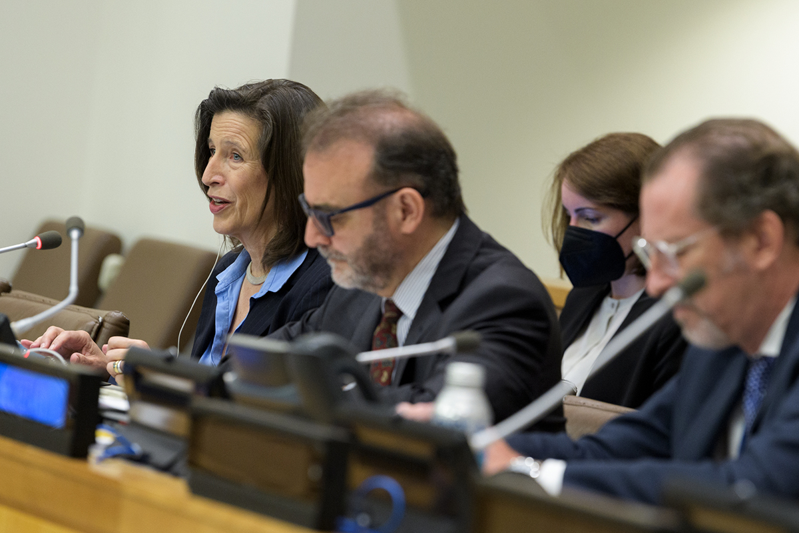
Figure #6: Officials from the UN Committee on Information

Possible Solutions
Similar to the direction that many governments are heading now, governments should enforce strict regulations on social media companies for how they delete and warn users about misleading content by establishing a standard. All platforms should employ a mechanism that informs the user of potential misinformation on certain posts and direct them to a more reputable source. If a post is continuously flagged by users, the platform must establish a procedure to take it down. All algorithms should employ “pre-bunking” to some extent, steering users towards posts from credible sources before they are exposed to other posts online. In fact, using machine learning technology, social media should be able to glean the potential political alignments of media sources and alert users of such. The algorithms should be programmed to break the echo chamber by occasionally introducing posts with opposing or less polarized views to users’ feeds.
Secondly, media literacy should be an integral part of K-12 education so the next generation can more effectively recognize misinformation. Schools can choose to implement media literacy training classes at certain points throughout the school year and discuss these topics whenever projects require online research. The same requirement for media literacy training can be enforced on companies as part of annual training for their employees.
Lastly, government sources should frequently produce FAQs, video tutorials, and other resources on hot topics to provide a reliable stream of information. Prior to an election, journalists should be encouraged to report on topics that may be confusing or controversial early on to better inform voters, and they should consult nonpartisan experts in the process. Moreover, governments should create an online communication protocol in times of disaster which clarifies the facts before false rumors can circulate online.
Thus, preventing the spread of misinformation online is a collaborative effort between government, online platforms, and the user, and solutions that address all three are bound to be most effective.

Bibliography
Works Cited

ABC News. “Americans’ Faith in Election Integrity Drops: POLL.” ABC News, 6 Jan. 2022, abcnews.go.com/Politics/americans-faith-election-integrity-drops-poll/story?id=82069876.
Biddlestone, Mikey, and Sander van der Linden. “Climate Change Misinformation Fools Too Many People – but There Are Ways to Combat It.” The Conversation, 28 Oct. 2021, theconversation.com/climate-change-misinformation-fools-too-many-people-but-there-are-ways-to-combat-it-170658.
Calefati, Jessica. “Fact-Check: Did Trump Tell People to Drink Bleach to Kill the Coronavirus?” Austin American-Statesman, 13 July 2020, www.statesman.com/story/news/politics/elections/2020/07/13/fact-check-did-trump-tell-people-to-drink-bleach-to-kill-coronavirus/113754708/.
Carmichael, Jack Goodman and Flora. “The Bill Gates “Microchip” Claim Fact-Checked.” BBC News, 30 May 2020, www.bbc.com/news/52847648.
Chee, Foo Yun. “Meta, Google, Twitter Vow to Fight Fake News Better as EU Gets Tougher.” Reuters, 16 June 2022, www.reuters.com/technology/meta-google-twitter-pledge-better-fight-fake-news-or-risk-fines-2022-06-16/. Accessed 22 Aug. 2022.
Coleman, Alistair. ““Hundreds Dead” because of Covid-19 Misinformation.” BBC News, 12 Aug. 2020, www.bbc.com/news/world-53755067.
Confessore, Nicholas. “Cambridge Analytica and Facebook: The Scandal and the Fallout so Far.” The New York Times, 4 Apr. 2018, www.nytimes.com/2018/04/04/us/politics/cambridge-analytica-scandal-fallout.html.
Kirby, Jen. “Trump’s Own Officials Say 2020 Was America’s Most Secure Election in History.” Vox, 13 Nov. 2020, www.vox.com/2020/11/13/21563825/2020-elections-most-secure-dhs-cisa-krebs.
Lynas, Mark, et al. “Greater than 99% Consensus on Human Caused Climate Change in the Peer-Reviewed Scientific Literature.” Environmental Research Letters, vol. 16, no. 11, 19 Oct. 2021, p. 114005, 10.1088/1748-9326/ac2966.
Muhammed T, Sadiq, and Saji K. Mathew. “The Disaster of Misinformation: A Review of Research in Social Media.” International Journal of Data Science and Analytics, 15 Feb. 2022, 10.1007/s41060-022-00311-6.
North, Anna. “The Long, Strange History of Anti-Vaccination Movements.” Vox, 4 Mar. 2022, www.vox.com/the-goods/22958419/covid-vaccine-mandate-pandemic-history.
Pierpoint, George. “Kerala Floods: Fake News “Creating Unnecessary Panic.”” BBC News, 20 Aug. 2018, www.bbc.com/news/world-asia-india-45245999. Accessed 22 Aug. 2022.
Rodriguez, Gabriel R. Sanchez, Keesha Middlemass, and Aila. “Misinformation Is Eroding the Public’s Confidence in Democracy.” Brookings, 26 July 2022, www.brookings.edu/blog/fixgov/2022/07/26/misinformation-is-eroding-the-publics-confidence-in-democracy/.
Ruby Edlin, and Mekala Panditharantne. “Information Gaps and Misinformation in the 2022 Elections | Brennan Center for Justice.” Www.brennancenter.org, 2 Aug. 2022, www.brennancenter.org/our-work/research-reports/information-gaps-and-misinformation-2022-elections#footnote3_7mtk95w. Accessed 22 Aug. 2022.
Satariano, Adam. “Russia Sought to Use Social Media to Influence E.U. Vote, Report Finds.” The New York Times, 14 June 2019, www.nytimes.com/2019/06/14/business/eu-elections-russia-misinformation.html. Accessed 22 Aug. 2022.
Suciu, Peter. “Spotting Misinformation on Social Media Is Increasingly Challenging.” Forbes, 2 Aug. 2021, www.forbes.com/sites/petersuciu/2021/08/02/spotting-misinformation-on-social-media-is-increasingly-challenging/?sh=7591ab392771. Accessed 22 Aug. 2022.
Union of Concerned Scientists. “Disinformation | Union of Concerned Scientists.” Www.ucsusa.org, www.ucsusa.org/climate/disinformation.
United Nations. “Committee on Information.” United Nations, www.un.org/en/ga/coi. Accessed 22 Aug. 2022.
United Nations. “Concluding Session, Committee on Information Calls for Fighting Misinformation, Protecting Journalists | UN Press.” Press.un.org, 13 May 2022, press.un.org/en/2022/pi2301.doc.htm. Accessed 22 Aug. 2022.
United Nations. “UN’s Rights Council Adopts “Fake News” Resolution, States Urged to Take Tackle Hate Speech.” UN News, 1 Apr. 2022, news.un.org/en/story/2022/04/1115412.
US Department of State. “Russia’s Disinformation Cannot Hide Its Responsibility for the Global Food Crisis.” United States Department of State, 22 June 2022, www.state.gov/disarming-disinformation/russias-disinformation-cannot-hide-its-responsibility-for-the-global-food-crisis/.
VOA News. “Russian Disinformation Spreading in New Ways despite Bans.” VOA, 9 Aug. 2022, www.voanews.com/a/russian-disinformation-spreading-in-new-ways-despite-bans-/6694083.html. Accessed 22 Aug. 2022.
Walker, Mason, and Katerina Eva Matsa. “News Consumption across Social Media in 2021.” Pew Research Center’s Journalism Project, Pew Research Center, 20 Sept. 2021, www.pewresearch.org/journalism/2021/09/20/news-consumption-across-social-media-in-2021/.

Images‌
Calabrese, Erin. “5 Ways to Spot Disinformation on Your Social Media Feeds.” ABC News, ABC News, 7 Jan. 2020, abcnews.go.com/US/ways-spot-disinformation-social-media-feeds/story?id=67784438.
Council on Foreign Relations. “A Scorecard for Dr. Tedros as the WHO’s Director-General.” Council on Foreign Relations, 4 May 2018, www.cfr.org/blog/scorecard-dr-tedros-whos-director-general. Accessed 22 Aug. 2022.
Murphy, Matt. “Capitol Riot Hearings: Eight Key Moments.” BBC News, 22 July 2022, www.bbc.com/news/world-us-canada-62263279. Accessed 22 Aug. 2022.
Nations, United. “Committee on Information.” United Nations, www.un.org/en/ga/coi.
Pierpoint, George. “Kerala Floods: Fake News “Creating Unnecessary Panic.”” BBC News, 20 Aug. 2018, www.bbc.com/news/world-asia-india-45245999.
Szabo, Liz. “How Anti-Vaccine Activists Are Using COVID-19 to Boost Their Movement.” Spectrum | Autism Research News, 28 Apr. 2020, www.spectrumnews.org/opinion/how-anti-vaccine-activists-are- using-covid-19- to-boost-their-movement/.

‌

