Forum: Special Conference
Issue: Ensuring fair access to medicines, vaccines, and medical equipment without distinction of any race, nationality, and religion
Student Officer: Candace Chen
Position: Deputy President of the Special Conference

Introduction
The on-going pandemic has resulted in a global shortage of medical staff and medical supplies. These consequences have increasingly worsened the pre-existing issue of medical discrimination in different countries. Various groups of people around the world often face barriers when trying to seek help from the health care industry. Although the reasons may vary depending on the country and community, there is one undeniable fact, that patients in regions where health care can be easily accessible are still confronted with unfair medical treatments due to discriminatory practices or systems. Health care providers often refuse to offer their services to patients due to the patients’ race, religion, or nationality. There are also cases where patients who have the same illness are treated unequally due to the physician’s subconscious prejudice. For instance, when an African American is diagnosed with the same condition as a Caucasian individual, physicians provide different medical care options for the two racial populations. The reason for that is because health care providers tend to assume that African-American individuals are from a minority group with a lower economic status, therefore, the providers are more inclined to offer treatments that are less expensive and less effective. As a result, patients in a minority or a socially disadvantaged group often have a higher chance of experiencing more severe illnesses, more unpleasant outcomes, as well as deaths that can be prevented. For example, due to the COVID-19 outbreak, there has been a staggering racial separation in the COVID-19 deaths in the United States of America (USA). While African-Americans have died at a rate of 69.7 per 100,000 people, the Caucasians have only died at a rate of 32.2. Apart from the unreasonable assumptions and treatments for the African American race, the Asian community faces an entirely different issue. During the difficult times of the pandemic, where the number of frontline workers was limited, patients with perceived discrimination often lacked access to proper medical service because they refused to be treated by Asian-American medical professionals. However, when compared to the Asian race, the impacts are still more significant in other racial and religious groups.
Although several countries have removed punitive laws that deny patients’ access to health care services, the majority of governments still have bills and policies that allow health care providers to refuse treatment based on discriminatory prejudice. For example, in Australia, the proposal of the religious discrimination bill will allow health care workers to decline their offering of services for certain patients due to their religious beliefs. The act of denying service based on discriminatory prejudice is not only related to the health care industry, but the complexity of this issue also reaches within the jurisdiction of the basics of the human rights law. Therefore, the solution to this issue lies between the balance of respecting health care provider’s rights and protecting the basic human rights of patients.

Definition of Key Terms

Health care

Health care is a service provided by medical professionals to maintain or improve the health of individuals through ways such as diagnosis, treatment, and recovery of illness, injury, or any form of physical or mental impairments. Health care can be accessed differently depending on the social or economic condition of individuals, as well as health-related policies set out by various governments. In this context, health care will be defined as a system that offers medical-related support or equipment for those in need. The system adopted by each country may vary, but the most common types are the universal government-funded healthcare, universal public insurance health care, universal public-private insurance health care, universal private insurance health care, and non-universal insurance health care. Universal government-funded healthcare is accessible for all citizens while universal public insurance health care is only available for those who are employed and have social insurances. On the other hand, universal public-private insurance is similar to universal public insurance, but one difference is that it allows people to receive healthcare via private insurance. Universal private insurance health care is only available for those with private insurances.

Discrimination

Discrimination is an act or practice of making personal biases to distinguish between human beings. Often, discrimination can occur with factors like race, gender, ethnicity, age, etc. When an individual acts based on discrimination, they often end up treating another group or individual in a prejudicial way (usually unjustifiably treating them). In the health care system and industry, discrimination often occurs when medical professionals allow their perception of the patients to influence their behaviors at work, which often leads to wrongful treatments for the patients.

Vaccine
A vaccine is defined as a biological preparation that improves immunity to a particular disease. Typically, a vaccine contains a weakened or killed form of the pathogen that is known to cause diseases in humans. When the vaccine enters the human body, it won’t cause any illness, but rather stimulate an immune response. Therefore, if afterwards the individual has any encounters with these diseases, the immune system will easily recognize and destroy those disease-causing microorganisms before the infection spreads within the human body. To put it in simpler terms, a vaccine prevents an infection before it even happens by making the immune system aware of the origin of the disease, which helps the system to effectively deal with the disease in the future.

History & Developments

The right to health
To acknowledge the importance of this issue, one must first acknowledge the basic human rights. The reason why the occurrences of discrimination in the health care system have become an issue in the first place is that medical professionals mistreat a patient based on personal biases, violating the fundamental human rights adopted in the constitution of the World Health Organization (WHO) in 1946. The constitution defines the right to health to be entitled to every human being regardless of race, religion, economic or social status and allow individuals to receive the highest attainable standard of health. The right to health is then further supported by the United Nations’ (UN)’s Universal Declaration of Human Rights, drafted in 1948. Yet, the existence of discrimination serves to exclude disadvantaged populations or minorities from receiving quality health treatment, therefore, individuals in these populations are often disproportionately affected by some of the world’s deadliest diseases. If minority populations who have access to health care and treatment, but are still being denied the service due to uncontrollable factors like race or nationality, then that becomes a clear violation of human rights in health. Without resolving this issue, the unfairness of the medical services will continue to act as a powerful barrier stopping nations from fulfilling their duties to ensure their citizens receive basic health-related human rights.

Victims from minority groups
Although medical discrimination can occur to every individual who seeks help from the health care system, targeted minority populations tend to experience these unfair treatments more often than others.

Racial/ethnic discrimination

One problem that minorities face in health care is racial and ethnic discrimination. For example, in the United States of America (USA), there is a significant portion of prejudicial behavior that is aimed at African-Americans. It’s not just the previous example of the COVID-19 death toll in the USA, in general, African-Americans are also more likely to suffer and die from chronic diseases like diabetes, hypertension, or obesity. These non-communicable diseases place them at a higher risk of mortality from deadly infectious diseases like COVID-19.
Figure #1: COVID-19 death rate per 100,000 people among racial groups in the USA, APM Research Lab 2020

According to a WebMD study, roughly around 4 in 10 doctors admit that they have some degree of bias or prejudice, whether it be racial, religious, or gender-based. Although there are limitations to these surveys, the data shows an undeniable fact that to a certain extent, intentional or unintentional personal prejudices will always exist within the minds of medical professionals when providing services or treatment. However, apart from the unresolvable biases, the causes of unfair access to medical help might not all be because of doctors. Another unintentional cause of racial discrimination in the health care system comes from its seemly race-blind metric. Researchers found that companies tend to offer health service algorithms that are inclined to favor the Caucasian patients over their African-American counterparts when it comes to giving out important medical treatment suggestions. The algorithm ranks the priorities of the patients based on the cost of their past treatments since African-Americans usually incur less medical cost than other patients, the algorithm tends to equalize a patient with minor diseases but has a higher medical expense in the past to an African-American patient with severe diseases but has a lower medical expense in the past. This unintentional racism and the seemly race-blind metric is one of the other causes of racial discrimination in the health care system.

Religious discrimination

Health care discrimination is not just limited to racial bias. Apart from the more common issue of racial discrimination in the medical field, religion-based discrimination plays a role in physician’s behavior and treatment for their patients. Oftentimes, in various parts of the world, patients who need medical assistance can be turned down by their physicians due to religious reasons. Although countries like Sweden and Finland restrict doctors from refusing to provide any legal medical service, countries like Australia, Canada, the United Kingdom (UK) and the USA all have laws that allow conscientious objection and for medical professionals to turn down a patient or refuse to provide care if it conflicts with their religious beliefs. These rules prioritize the religious convictions of the health care providers over the patient’s need for medical support. This can result in multiple consequences and negative impacts for both the patients’ wellness and the health care providers’ reputation. Although religious conflicts mostly occur when performing services like abortion, there are still instances where doctors use the excuse of religious conflict in an illogical way to refuse to treat patients. Using the current pandemic as an example, in England and Wales, the mortality rate is higher among Muslims than any other religions like Hinduism or Christianity. Similar to racial discrimination, discriminatory behaviors based on religious beliefs are very much possible within the medical industry, and health care providers as well. Therefore, this issue must be addressed and solved.

Impacts and Consequences

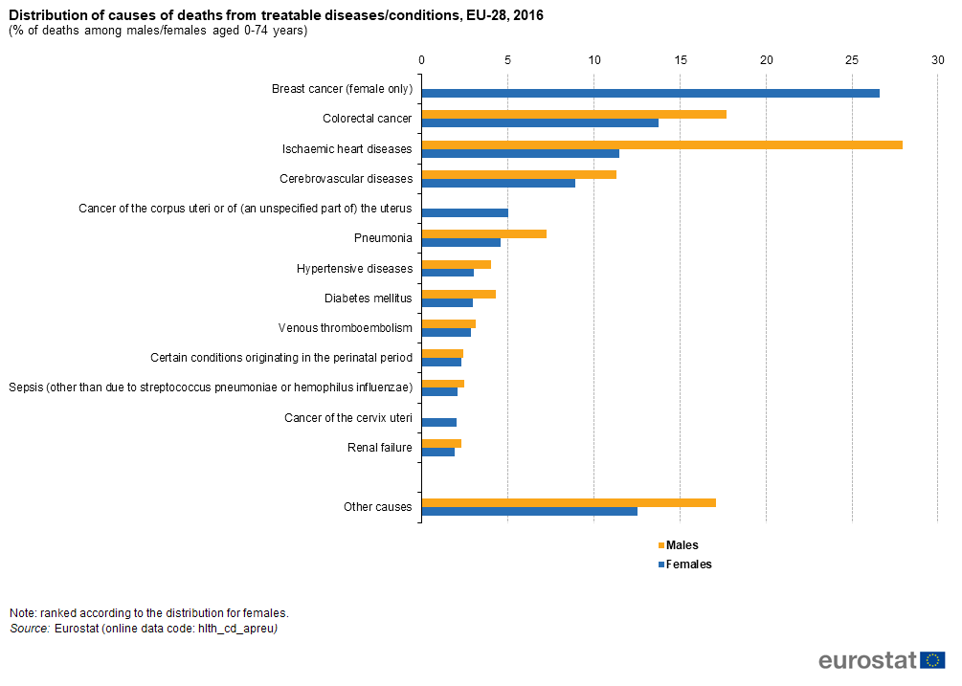
Increase in the number of preventable deaths

One of the major consequences of health care discrimination and unfair medical treatment with the distinction of race, nationality, and religion is the distressing number of preventable deaths each year. Using the EU as an example, apart from other causes, a significant number of preventable deaths are caused by diseases and illnesses that were commonly seen among the individuals of minority groups. For example, cancer or heart diseases both have high preventable death rates, and those same illnesses are also the ones that can easily spread within a certain racial or religious community. That means with ethnicity and religious discrimination, there will be more of these unpreventable deaths because these people cannot receive quality health care services. Also, by giving the victims of health care discrimination fair access to vaccines, the vaccine-preventable death rates will drop. Research showed that there might be racial disparities in influenza vaccination as a certain race might be inclined to refuse to get a vaccine due to historical distrust for the health care services provided. The study showed that in America, African-Americans are 40% less likely to get flu shots, which is concerning when it comes to receiving the potential vaccine for COVID-19 in the future. Therefore, countries must ensure fair access to vaccines as well as eliminate or curb the impacts of racial and religious discrimination.
Figure #2: Percent distribution of the cause of preventable deaths among male and female in the EU, Eurostat 2016

Lower life expectancy

Concerning the results of the increase in preventable deaths, another major issue is the life expectancy of the discriminated individuals. For instance, as mentioned previously, racial discrimination targets individuals from the African-American population. Therefore, on average, in the USA, the life expectancy of the African-American population is the lowest among other races, at around 75 years old. Meanwhile, in other countries, the natives tend to always out-live any other immigrant racial population. The same trend applies to religious discrimination in health care as well. It is estimated that, worldwide, Muslims tend to have the lowest lifespan when compared to other religions. The reasons for the alarmingly low life expectancy may vary depending on factors like housing, financial income, or pre-existing genetic diseases. However, the issue of discrimination in health care plays a major role in worsening life expectancy as well.

Geopolitics

USA
The USA, compared to other More Economically Developed Countries (MEDC), experiences severe impacts of health care discrimination whether it be racial, religious, or nationality-based. From the significant racial difference with the COVID-19 deaths to the proposed rules that allow health care providers to discriminate against certain groups of people without consequences to the reoccurring protests demonstrating for human rights or racial justice. As stated by the National Academy of Medicine (NAM), a non-profit institution of medicine in the USA, “some people in the United States were more likely to die from cancer, heart disease, and diabetes simply because of their race or ethnicity, not just because they lack access to health care”. Even with the same external influences like insurance status, income, age, and other pre-existing health conditions, there are still numerous differences between the health care services provided to a Caucasian individual and an African-American individual. For instance, an African-American with heart disease is more likely to get recommended an older, cheaper, and more conservative treatment. They are also less likely to receive coronary bypass operations and angiography and more likely to get an earlier and unsuitable discharge after the surgery. Yet, with all these trends and behaviors, the government still refuses to act on and solve the issue. For instance, the more prominent example of health care discrimination that happened recently includes a proposal made by the Trump Administration that allows health care discrimination against the LGBTQ community. The health care discrimination issue is already deeply embedded in the health care system of the USA; therefore, it is crucial to bring attention to this issue before more minorities die from discriminatory medical treatments.

Canada
Canada is known for its significant number of immigrants and universal health care. However, with nearly 315,000 immigrants in 2019, racial or religious discrimination can very much occur within its health care system. Generally, the type of discrimination that can happen frequently in a Canadian hospital is social discrimination, or more specifically, income-based discrimination. For instance, studies found that wealthier patients tend to have a higher chance (one out of four tries) of receiving an appointment while an individual with an unstable financial status has a lower chance of around one out of seven tries. Several medical professionals have also spoken up about the influences of a patient’s social status on the treatment they receive from the health care system. Regarding other forms of discrimination, Canada also often experiences racial discrimination in the health care system. For example, in an official clinical handbook for sickle cell disease patients, the report states, “Clinicians and administrators recognize that racism towards patients with SCD (sickle cell disease) does exist and must be addressed”. This handbook further emphasizes on the stereotypes given to a certain race when requesting for emergency care, like assuming individuals from the African-American race seeks medical help due to certain unlawful reasons (such as simply trying to obtain some medicine or medical equipment) whenever they claim they are in an SCD crisis.

Less Economically Developed Countries (LEDCs)
During a pandemic or a global outbreak of a virus, LEDCs often suffer greatly from a lack of medical access and assistance which often results in high casualties. This may be due to several reasons: insufficient medical funds, lack of medical infrastructure, or physicians without proper training. Not to mention the fact that citizens of the countries struggle to gain access to health care as many LEDCs like Ethiopia or Yemen adopt non-universal insurance health care as the primary health care system. That means the citizens will have to rely on their economic status to purchase private insurances because the medical services aren’t government-funded. In addition, the ones that need medical assistance the most is often those who are in poverty as they are most exposed to poor water quality, inadequate food portion, and low level of sanitation. Unlike the more developed countries, LEDCs usually experience medical discrimination in forms like gender discrimination or socioeconomic status discrimination. Due to the growth of the market economy, women are often excluded from the modern sector, meaning they are likely working for a low-income job. Combining the low income with a poor living environment, it is hard for women to receive quality medical care when in need. That results in a higher mortality rate among females, lower life expectancy, and less health care access.

Previous Attempts to Solve the Issue

Although several world leaders have acknowledged the consequences health care discrimination can cause to their citizens, the rules that the leaders have established to attempt to solve this issue is still insufficient as health care discrimination is still very much an inconvenience in some countries. However, fortunately, a few UN organizations have decided to take the matter into their own hands. Apart from resolutions that push for the elimination of general racial or religious discrimination, other UN organizations target the issue of health care discrimination specifically. For instance, United Nation Acquired Immunodeficiency Syndrome (UNAIDS), World Health Organization (WHO), along with a few other UN organizations acknowledged the issue of health care discrimination that prevents the fair access of necessary medical services. Therefore, by launching the Agenda for Zero Discrimination in Health Care, the UN organizations hope all member states can collaborate to resolve this issue. The plan can range between several actions like addressing the political barriers, as well as strengthening the power and leadership of medical associations. Several countries have since established regulations that prevent unjust medical treatment or revoked previous laws that allow health care discrimination, so to a certain degree, the agenda is successful in reducing health care discrimination. However, progress can still be made as there are still member states with rules that protect health care discrimination on religious-based reasons. It is also important to note that apart from the Agenda for Zero Discrimination in Health Care, there aren’t any other particularly notable changes or movements from the UN that targets health care discrimination. Nevertheless, compared to the past, the extent of discrimination in the health care industry has been reduced due to the successes of the Agenda for Zero Discrimination in Health Care.

Relevant UN Treaties and Events
- The Agenda for Zero Discrimination in Health Care is created by the WHO and UNAIDS. The agenda prioritizes in areas like political impact, implementation, and accountability with guidelines to ensure the protection of human rights and health
- Resolution A/RES/68/151 addresses the global efforts required to resolve any form of racial discrimination
- Resolution A/RES/36/55 calls for the elimination of all forms of religious discrimination

Possible Solutions

When writing a resolution to address the fairness in the health care system, delegates should all have a deep understanding of the health care systems in the country each delegate represents. Solutions can vary and depend on the different systems of health care employed by each country and the political ideology of each country. Delegates can start by addressing and removing any legal or political regulations that permit health care providers to largely involve their personal biases to the behaviors at work. For example, eliminate rules that give physicians the freedom to refuse care based on unreasonable religious reasons. Additionally, countries can implement laws that reduce or prohibit health care discrimination. Rules that ensure health care providers do not refuse service based on personal biases. Specifically, anti-discriminatory laws that protect the basic human rights of the targeted racial, ethnicity, or gender groups.

Furthermore, hospitals can recruit a more diverse faculty. Including staff with different nationalities, race, religion, gender, as well as age and other factors. This solution is beneficial in a few ways. First of all, it will allow patients who experienced discrimination to receive treatment with physicians they feel comfortable with. Secondly, a diverse faculty will provide medical professionals with an environment that understands and respects various kinds of people. Therefore, when treating patients with a difference in race, gender, religion, or age, the physicians will be able to handle the situation without causing any discomfort or discrimination.

Another solution would be to educate citizens and medical professionals. Patients who seek help from the health care system should be fully aware of their basic human rights. This can be done in ways like organizing educational courses in different education institutes or different workplaces. Not only is it important to educate citizens, but it is also important to educate health care providers. Inform the workers of their rules and rights, which says what can and cannot be done. Offer courses that provide doctors with a better understanding of what disease symptoms look like on different racial groups. For instance, a medical student from the USA claimed that doctors are often unclear about the ways a symptom can look on patients with a different race. Therefore, he compiled a list of COVID-19 symptoms on patients with darker skin color and wrote it into a handbook to help educate his fellow workmates.

This current issue of health care discrimination and unfair treatment with the distinction of race, nationality, or religion is recognized by many countries. If nations take action to resolve discrimination in health care systems, then many of the previously stated consequences will no longer exist.

Bibliography
Amin, Faiza. “Racial Bias Reaches Tipping Point in Canada's Healthcare System.” CityNews Toronto, 5 Dec. 2019, www.toronto.citynews.ca/2019/12/04/racial-bias-healthcare-system/.
Burns, Katelyn. “The Trump Administration Will Now Allow Doctors to Discriminate against LGBTQ People.” Vox, Vox, 24 Apr. 2020, www.vox.com/identities/2020/4/24/21234532/trump-administration-health-care-discriminate-lgbtq.
Byrd, W M, and L A Clayton. Race, Medicine, and Health Care in the United States: a Historical Survey. Mar. 2001, www.ncbi.nlm.nih.gov/pmc/articles/PMC2593958/.
COVID-19 deaths analyzed by race and ethnicity. (2020, July 22). Retrieved July 29, 2020, from https://www.apmresearchlab.org/covid/deaths-by-race.
Hayes, Ashley. Could Doctor Bias Be Affecting Your Treatment? 13 Jan. 2016, www.webmd.com/a-to-z-guides/news/20160113/doctor-bias-treatment.
Holden, Michael. “Muslims, Jews Have Higher COVID Death Rate, UK Figures Indicate.” Edited by Mark Heinrich, Reuters, Thomson Reuters, 19 June 2020, www.reuters.com/article/us-health-coronavirus-britain-religion/muslims-jews-have-higher-covid-death-rate-uk-figures-indicate-idUSKBN23Q1PN.
Human Rights and Health. 29 Dec. 2017, www.who.int/news-room/fact-sheets/detail/human-rights-and-health.
Johnson, Carolyn Y. Racial Bias in a Medical Algorithm Favors White Patients over Sicker Black Patients. 24 Oct. 2019, www.washingtonpost.com/health/2019/10/24/racial-bias-medical-algorithm-favors-white-patients-over-sicker-black-patients/.
Lesley, Posted by Alison. “Which Religion Will Have You Living The Longest?” World Religion News, World Religion News, 17 Apr. 2018, www.worldreligionnews.com/religion-news/religion-will-living-longest.
Monique Tello, MD. Racism and Discrimination in Health Care: Providers and Patients. 9 July 2020, www.health.harvard.edu/blog/racism-discrimination-health-care-providers-patients-2017011611015.
O'Donnell, Jayne. 'Tuskegee Always Looms in Our Minds': Some Fear Black Americans, Hardest Hit by Coronavirus, May Not Get Vaccine. 20 Apr. 2020, www.usatoday.com/story/news/health/2020/04/19/coronavirus-vaccine-black-americans-prevention/5146777002/.
Penan, Hayley. “New Federal Religious Refusals Rule Puts Beliefs of Providers Above Patient Care.” National Health Law Program, 9 May 2019, www.healthlaw.org/new-federal-religious-refusals-rule-puts-beliefs-of-providers-above-patient-care/.
Rapaport, Lisa. Should Doctors Have the Legal Right to Refuse Care? 5 Oct. 2016, www.reuters.com/article/us-health-medethics-doctor-rights/should-doctors-have-the-legal-right-to-refuse-care-idUSKCN1252CD.
Zero Discrimination in Health Care. 1 Mar. 2016, www.who.int/workforcealliance/media/news/2016/zero_discrimination/en/.

